Tasks To Be Performed:

1. Create a FIFO SQS queue and test by sending messages.

2. Register your mail in SES and send a test mail to yourself.

1. Create a FIFO SQS queue and test by sending messages.

**Create a FIFO SQS queue**

* SQS > Create queue
* Type > FIFO
* Name > test.fifo
* Configuration
* Visibility timeout > 30 sec
* Receive message wait time > 20 sec
* FIFO queue settings
* Content-based deduplication and High throughput FIFO queue ( check both)
* Encryption > disabled
* Reset all default
* Created Queue

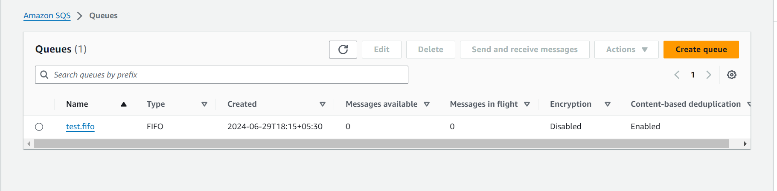

test by sending messages

select created Q  
Send and receive messages

Message body >type test massage

Message group ID > give any number ( like order no 1)

Message deduplication ID – Optional ( need to send same massage again give different orded name or number )

Sent massages

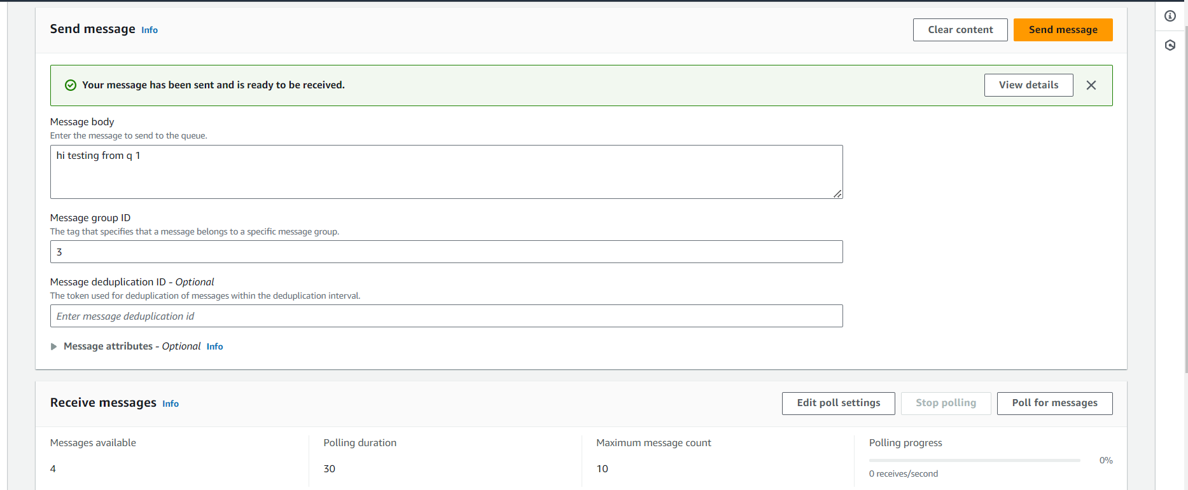

## Receive messages

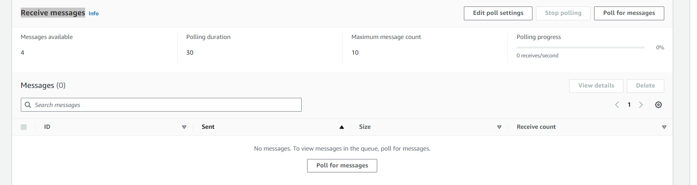

To consume massages > poll for it

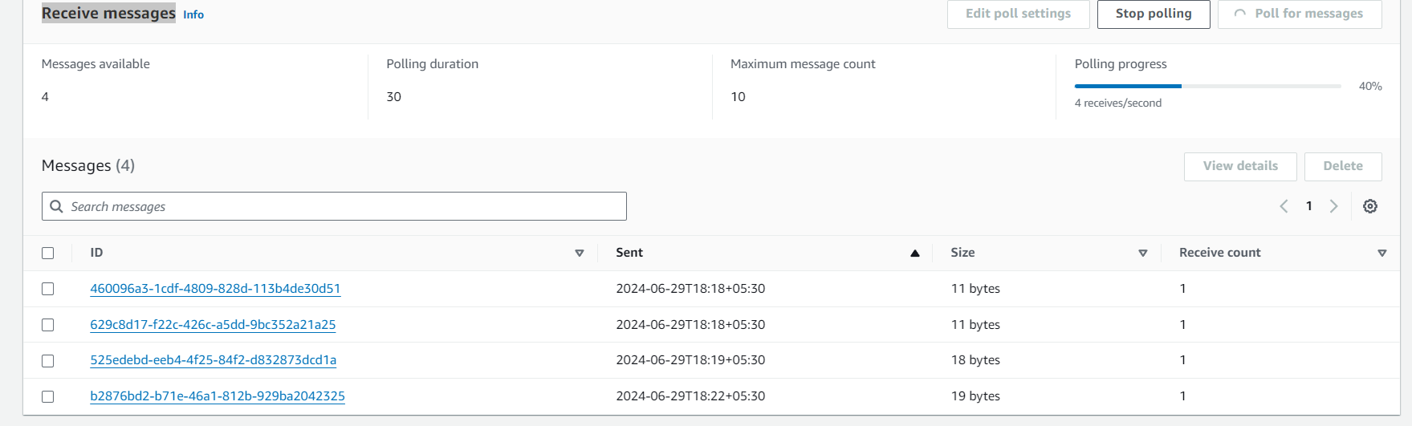

In the polling in progress only we have to delete or consume massages other wise it will get expire

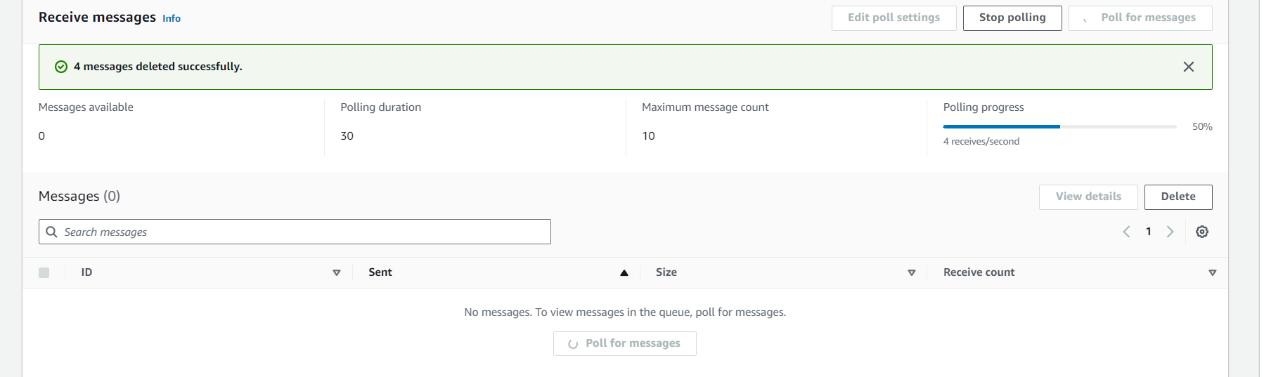

2. **Register your mail in SES and send a test mail to yourself.**

**Register your mail in SES**

**Go to identities**

## Create identity > Identity details > Email address ([karthikmsd797@gmail.com](mailto:karthikmsd797@gmail.com))> creates

* After creating you will get verification link to mentioned mail id just open it, it will get verified

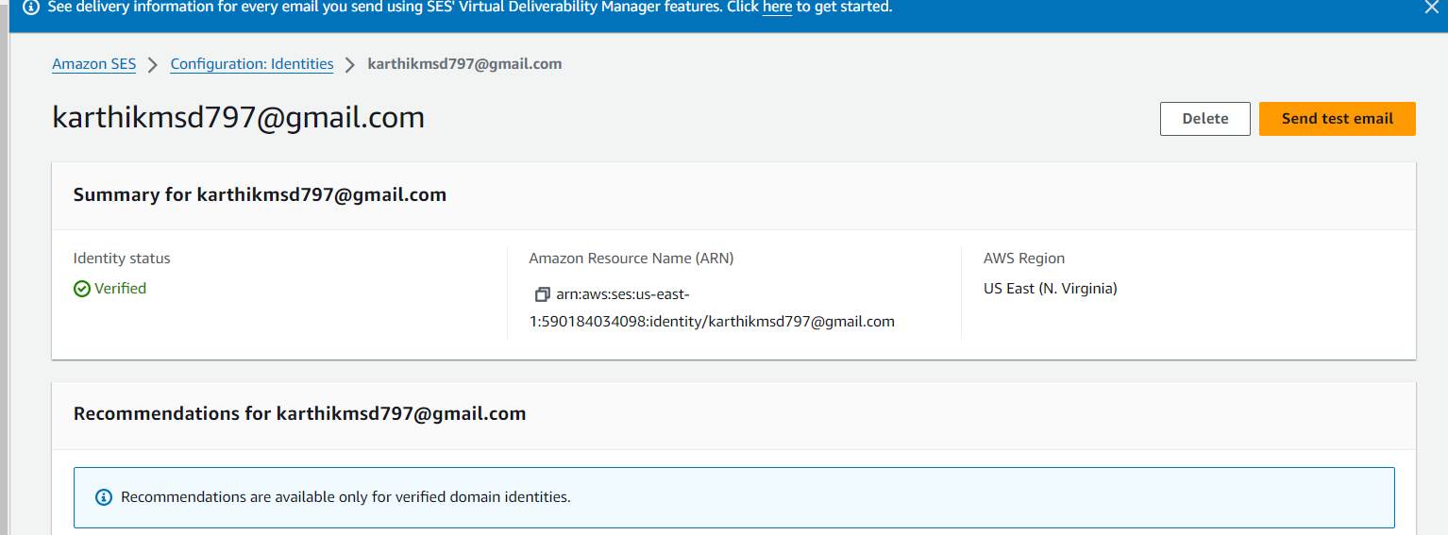

**send a test mail to yourself.**

* Send test email
* Message details > Formatted
* From-address > default yours
* Scenario > custom
* Scenario > again my mail id
* Subject > test mail
* Body – optional > hi this is test mail form AWS SES

